Name: Juliette Joseph-Odogbo
Course: Linux Administration
Assignment: AwkLab
Date: 10/08/22025

- Print all the First Names.
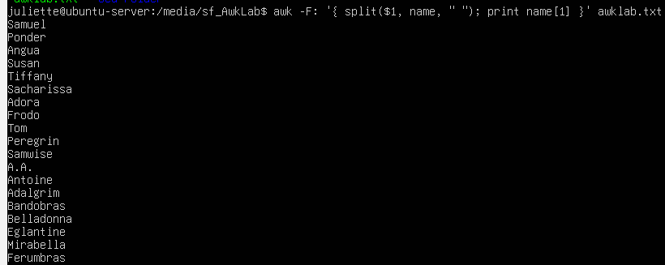

Command: awk -F: '{ split($1, name, " "); print name[1]}' awklab.txt.
How this command works
- awk → runs the awk program line by line.
- -F: → tells awk to split the line by colons.
- { } — Tells AWK what action to take when the rule matches.
- $1 → holds the full name (first and last).
- split($1, name, " ") → breaks the name into parts using spaces.
- The parts are saved inside an list called name.
- name[1] becomes the first name, name[2] the middle name (if any), name[3] the last name, and so on.

- print name[1] → prints only the first name for each line.
- awklab.txt → is the file I am working with.
Why this command works:
This command works because the -F: tells awk to split the line by colons, which makes $1 contain just the name section. Using split ($1, name, " ") breaks that name into smaller parts by spaces, so the first name is stored in name[1]. By printing name [1], I make sure only the first names are shown for each line in the awklab.txt file.
- Print phone numbers for Tom and Frodo after their names.

Command: awk -F: ‘$1 ~ /Frodo Baggins|Tom Bombadil/ {print $1, $2 }’ awklab.txt.
How this command works:
- awk → runs the awk program line by line.
- -F: → tells awk to use the colon to split each line into fields.
  - $1 = full name
  - $2 = phone number
- $1 ~ /Frodo Baggins|Tom Bombadil/ →
  - Looks at the first column ($1).
  - The slashes / / define the pattern I am searching for.
  - The | means OR, so it matches either Frodo Baggins or Tom Bombadil.
- {print $1, $2 } →
  - If a line matches, print $1 (the full name) and $2 (the phone number).
- awklab.txt → is the file awk reads.
Why this command works:
This works because -F: uses the colon to separate the line into columns. $1 holds the full name, and $2 holds the phone number. The pattern inside the slashes makes awk look only for lines with Frodo Baggins or Tom Bombadil in the first column. When it finds those lines, awk prints the name and phone number side by side.
- Print Peregrin’s full name and phone number area code only.
Command: awk -F: '$1 ~ /Peregrin Took/ { match($2, /\([0-9]{3}\)/, code); print $1, code[1] }' awklab.txt
How this command works:
  - awk → runs the awk program line by line.
  - -F: → tells awk to use the colon as a divider, splitting each line into parts. The first section is the name, and the second section or field starts with the phone number.
  - $1 → refers to the first part, which contains the full name (e.g., Peregrin Took).
  - ~ /Peregrin Took/ → the slashes are the pattern. This tells awk to look for the line where the name is Peregrin Took.
  - match($2, /\([0-9]{3}\)/, code) →
  - $2 is the second section, which has the phone number.
  - match() searches inside $2 using the number rule we gave it.
  - [0-9] means any digit from 0 to 9.
  - {3} means exactly three digits in a row.
  - \( and \) mean I am looking for three digits inside the brackets, like (510).
  - code[] stores those three digits, which represent the area code.
  - print $1, code[0] → $1 prints the full name, and code[0] prints the area code associated with Took.
Why this command works:
This works because the colon acts as a divider between the name and the phone number. $1 gives us Peregrin’s full name, while match() looks inside $2 and pulls out only the three digits inside the brackets. Since those digits are stored in code[1], I can print the name together with just the area code, instead of the whole phone number.
- Print all phone numbers (full number) in the 123-area code along with the names.
Command: awk -F: `$2 ~ /\(\123\) / { print $1, $2 }` awklab.txt.
How this command works:
How this command works:
- awk → the tool used to scan the file line by line.
- -F: → tells awk to use the colon (:) as the divider between parts of the line.
  - This separates names into one column, phone numbers into another, and so on.
- $2 → refers to the second column, which contains the phone number.
- ~ → means “check if this column matches the pattern.”
- / / → the slashes hold the regular expression (pattern) we are searching for.
- $123$→ looks for the digits 123 inside real parentheses.
  - The backslashes \( and \) make sure awk understands these are literal ( and ) characters, not special regex symbols.
- { print $1, $2 } → if the pattern matches, awk prints:
  - $1 → the full name
  - $2 → the full phone number
- awklab.txt → is the file awk reads line by line.
Why this command works:
This works because -F: splits each line into separate fields, making it easy for awk to identify the name ($1) and the phone number ($2). The pattern \(123\) inside the slashes focuses specifically on phone numbers with the 123 area code inside parentheses. When awk finds a match in the second column, it prints the name and number side by side. This way, the output shows only the people whose phone numbers have the 123-area code.

- Print all Last names beginning with either a T or D (careful of middle names!
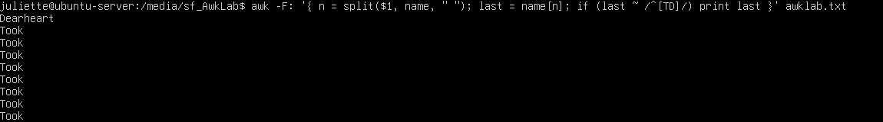
Command: awk -F: ‘ { n = split($1, name, “ “); last = name[n]; if (last ~ /[TD]/) print last }’ awklab.txt .
How this command works:
I start with awk -F ':'. This runs the awk command and tells it to use the colon as the divider between the different columns in the file.
Next is n = split($1, name, " "). Here, I look at the first column ($1), which has the full name. The split breaks that name into smaller parts — like the first, middle, and last name — using spaces as the divider “ “.
The n holds the number of parts that were created after the split. So, if the name has two parts, n = 2; if it has three parts, n = 3. This helps awk know how many pieces are in the name.
last = name[n] picks out the last part of the name based on that number in n.
The if (last ~ /[TD]/)
f (last ~ /[TD]/)
- if → starts a condition. Awk will only run the code inside { } if this condition is true.
- last → is the variable holding the last name.
- ~ → means “matches this pattern.” Awk checks whether the text in last fits the pattern that follows.
- /[TD]/ → is the actual pattern:
  - The [ ] means “match any single character inside the brackets.”
  - T and D inside the brackets mean awk will look at the last names in the file that begins with T or D

Finally, print last prints out the last names that match the condition in the if statement.
Why this command works:
This works because -F ':' tells awk to use the colon to split the line into different sections, so it can easily focus on the name part in the first column. Then I use split to break that name into smaller pieces using spaces. The number n just shows how many parts the name has, so we can grab the last one no matter how many names are there. The if part is like a quick check — it looks at the last name and asks, “does it start with T or D?” If it does, awk prints it. That is why I only see last names that begin with T or D in the output.
- Print all first names containing four or less characters.
Command: awk -F: ‘{ split($1, name, “ “); if (length(name[1]) <= 4) print name[1] }’ awklab.txt
How this command works:
- -F ':' → tells awk to use the colon as the divider between different fields in the file.
- { } — Tells AWK what action to take when the rule matches.
- split($1, name, " ") → splits the first field (the full name) into smaller parts (first, middle, last names).
- name → holds the result of splitting the first field.
- " " → tells awk to split the name based on spaces.
- if (length(name[1]) <= 4) → checks if the first name is 4 characters or less.
- print name[1] → prints the first names that match this condition.
Why this command works:
- -F ':' splits the line into separate fields so awk can focus on the name field.
- split breaks the full name into smaller parts so we can isolate the first name.
- The if statement checks if the first name matches four or less characters.
- If it does, print displays that first name.
- This makes sure only short first names show up in the output.

- Print the first names and area codes of all those in the 916-area code.
Command: a
How this command works:
- awk -F: → The -F: option tells awk to use the colon (:) as a divider between fields. This separates the line into sections: the first field holds the name, the second holds the phone number, and the others hold contribution data.
- { } — Tells AWK what action to take when the rule matches.
- split($1, name, " ") → Takes the first field (the full name) and splits it into smaller pieces using spaces “ “ as the divider. This way, the first name is stored in name[1], and any middle or last names are in later indexes.
- if ($2 ~ /\(916\)/) → Checks the second field (phone number) to see if it contains the pattern (916). The ~ means “matches this pattern.” If the phone number has this area code, awk moves on to the next step.
- match($2, /\([0-9]{3}\)/, code) → This looks inside the phone number field and extracts the 3-digit area code:
  - The / and / mark the start and end of the pattern.
  - \( and \) tell awk to look for literal parentheses around the number.
  - [0-9] means “any digit from 0 to 9.”
  - {3} means “exactly three digits in a row.”
  - Combined, \([0-9]{3}\) means: “an opening parenthesis, followed by three digits, followed by a closing parenthesis.”
  - The code variable is where awk stores the area code it finds.
- print → tells awk what to display in the output.
- name[1] → this is the first name, which I got earlier using the split function.
- , (comma) → puts a space between the outputs (first name and area code).
- code[0] holds the exact text that was matched by the pattern — in this case, something like (916) — and that’s what gets printed after the first name.
So together, print name[1], code[0] says: print the first name followed by the area code associated with that first name
Why this command works:
The reason why this command works is because the -F: option divides each line into separate fields, allowing awk to treat the name and phone number as two different sections. The split function then breaks the first section($1) into smaller parts so that I can isolate and work with just the first name. The if statement checks the second section($2) of the line to find phone numbers that contain the (916) area code, ensuring I only target the right group of people. The match function is used to extract the three-digit area code from the phone number so that we can print it separately. Finally, the print statement displays the first name and the area code together. Each part works step by step—first dividing, then finding, then extracting, and finally printing exactly what the question is asking for.
- Print Sacharissa’s campaign contributions following her name. Each value should be printed with a leading dollar sign; e.g., $250 $100 $175.
Command: awk -F: '$1 ~ /Sacharissa/ { print $1 “:” "$"$3, "$"$4, "$"$5 }' awklab.txt
How this command works:
- awk -F: → The -F: splits each line using the colon as a divider, separating the name, phone number, and each contribution into their own fields.
- $1 ~ /Sacharissa/ → This checks the first field (the full name) and finds the line that contains the word “Sacharissa.” Once it finds that line, awk executes the print action.
- print $1 → This prints Sacharissa’s full name first.
- “:” "$"$3, "$"$4, "$"$5
- The “:” is the semi colon after the second field
- The $ in quotes ("$") is used to add a dollar sign in the output.
- "$"$3 means: print a dollar sign followed by the value in field 3, which is 250.
- The same applies for $4 (100) and $5 (175).
- The commas between them insert spaces automatically
Why this command works:
The reason why this command works is because the -F: separates each line into different fields, allowing awk to treat the name, phone number, and contributions separately. For Sacharissa’s line, the fields are her full name in $1 and her contributions in $3, $4, and $5. The $1 is printed first to display her name. Then, the dollar sign inside quotes ("$") is added before $3, $4, and $5 so that each contribution is printed with a leading dollar sign. This way, the command prints her name followed by each of her contributions in the required format.
- Print last names followed by a comma and the phone number. Be careful of the last names’s format.
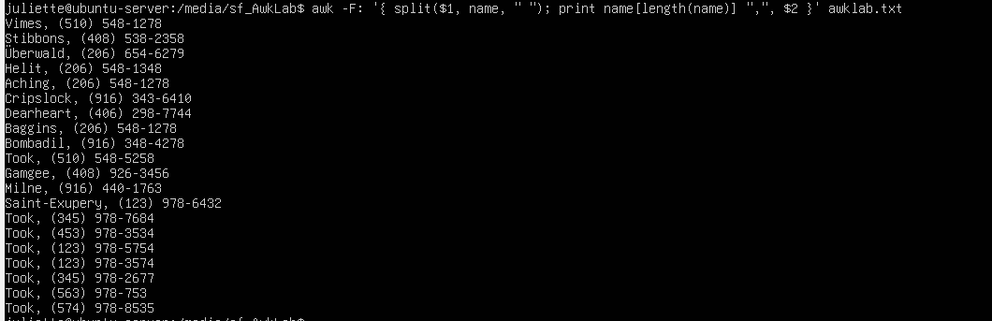
Command: awk -F: ‘{ split($1, name, “ “); print name[length(name)] “,”, $2 }’ awklab.txt.
- -F: → splits each line using the colon as the divider, so the name goes in $1, the phone number in $2, and contributions in $3 and beyond.
- { } — Tells AWK what action to take when the rule matches.
- split($1, name, " ") → breaks the full name into separate pieces wherever there’s a space. Each piece is stored in a list called name.
- name[length(name)] → picks the last piece in that list, which is the last name. I use length(name) because not all names are the same length. Some people only have two names, but others have three or more. This way, awk always takes the final part of the name, no matter how long it is.
For “Samuel Vimes” → name[2] = Vimes
For “Antoine de Saint-Exupery” → name[3] = Saint-Exupery
- "," → adds a literal comma after the last name.
- $2 → prints the phone number.
- print name[length(name)] ",", $2 → puts it all together, showing the last name followed by a comma and the phone number.
Why this command works:
The reason this command works is because the -F: separates each line into fields, allowing awk to treat the name and the phone number as separate sections. The split function then breaks the full name into smaller parts, which lets me work with only the last piece. Using name[length(name)] ensures I always pick the last name correctly, even for people with long names like “Antoine de Saint-Exupery.” Finally, the print statement displays the last name followed by a comma and the phone number, which matches exactly what the question is asking for.
- Print the first and last names of those who contributed more than $110 in the last month. Make sure to include their last month contribution amount after the name.
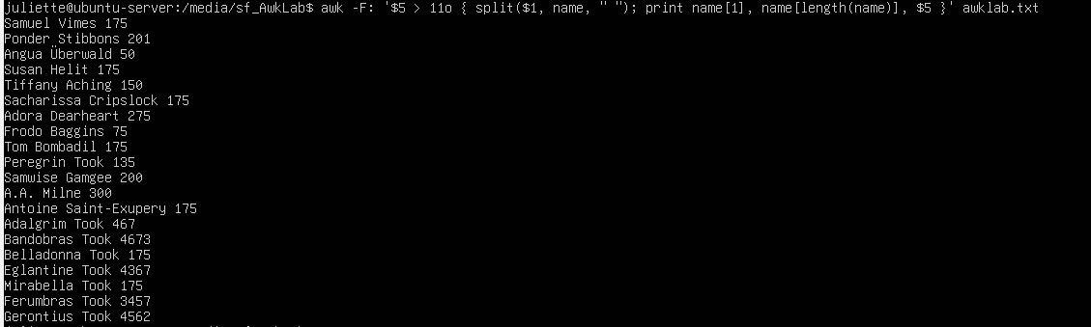
Command: awk -F: ‘$5 > 110 { split($1, name, “ “); print name(1), name[length(name)], $5 }’ awklab.txt
How this command works:
- awk -F: → The -F: tells awk to use the colon (:) as a divider to split each line into fields. This separates the name, phone number, and each month’s contributions.
- { } — Tells AWK what action to take when the rule matches.
- $5 > 110 → This is the condition. It checks if the last month’s contribution (field 5) is greater than 110. Only those records that meet this condition will be printed.
- split($1, name, " ") → Splits the full name in $1 into smaller pieces wherever there’s a space. This allows us to handle both simple and longer names
- name[1] → Picks the first name, which is always the first piece after splitting.
- name[length(name)] → Picks the last name. Using length(name) makes it work for names with middle parts too (like “Antoine de Saint-Exupery”), ensuring I always grab the last part correctly.
- print name[1], name[length(name)], $5 → Prints the first name, last name, and the numeric value of their last month’s contribution.

Why this command works:
The option -F: is what lets AWK split each line correctly. Since the file uses colons (:) to separate the fields, AWK knows to treat the name as one field ($1), the phone number as another ($2), and the contributions as later fields. This makes it possible to isolate the last month’s contribution in $5.
The condition $5 > 110 checks the value in the fifth field (last month’s contribution). If the number in this column is greater than 110, AWK decides to keep the line and run the print statement. If it is not greater than 110, that line is skipped.
The split($1, name, " ") is important because the $1 field contains both the first and last names together. By splitting $1 at the space, the first name gets stored in name[1] and the last name in name[length(name)]. This makes sure you do not lose the last name even if someone has a middle name.
The print name[1], name[length(name)], $5 part then puts it all together:
- name[1] prints the first name.
- name[length(name)] prints the last name (even if there’s a middle name in between).
- $5 prints the last month’s contribution amount.
Because the if condition only allows lines where $5 > 110, the final output shows only the people who contributed more than $110 in the last month, along with their first and last names, and the exact contribution amount.

  - Print the last names, phone numbers, and first month contribution of those who contributed less than $150 in the first month
Command: awk -F: '{ split($1, name, " "); if ($3 < 150) print name[length(name)] ":" $2 ":" $3 }' awklab.txt
How this command works:

How this command works:
- awk -F: → Starts AWK and tells it to use the colon (:) as the field separator.
  - $1 = full name (first, middle, last)
  - $2 = phone number
  - $3 = first month contribution
- The curly braces { } tell AWK what to do when the if condition is true.
- The single quotes '' hold the AWK program so it runs on every line.
- split($1, name, " ") → Splits the full name (field 1) into parts wherever there is a space.
  - name[1] = first name
  - name[length(name)] = last name (this works even if there’s a middle name).
- if ($3 < 150) → Checks the third field (first month contribution). If the value is less than 150, then the print action runs. If not, that line is skipped.
- print name[length(name)] ":" $2 ":" $3 → Prints:
  - the last name,
  - followed by a colon,
  - then the phone number,
  - another colon,
  - and finally, the first month contribution.
This keeps the output in the same field:field:field style as the original file.

Why this command works:
The -F: ensures AWK can treat each part of the line as a separate field. The split makes it possible to pull out just the last name from $1, instead of printing the entire full name. The if condition filters so only people who contributed less than $150 in the first month are included. Finally, the print statement rebuilds the output in the correct format, showing last name : phone number : contribution, which matches exactly what the question is asking for.

12. Print the first names and contribution of those who contributed between $10 and $200 in the first month.
Command: awk -F: '{ split($1, name, " "); if ($3 >= 10 && $3 <= 200) print name[1] ":" $3 }' awklab.txt
How this command works:
- awk -F: uses the colon : to split each line into sections (name, phone number, contributions).
- The single quotes '' wrap the AWK action so it runs line by line.
- The curly braces { } mean “do this action if the condition is true.”
- split : → Starts ($1, name, " ") → Splits the first section ($1, which is the full name) into smaller parts like first, middle, last, and stores them in the variable name.
- if ($3 >= 10 && $3 <= 200) → These checks if the first month contribution (field 3) is between 10 and 200.
- print name[1] ":" $3 → Prints the first name (name[1]) followed by a colon and the contribution from field 3 which is the field for contribution.
Why this command works:
The -F: splits each line into fields so AWK can tell names and numbers apart. The split lets us grab just the first name from the full name. The if statement makes sure; I only look at people whose first month contribution is between 10 and 200. The print statement then prints the first name and the contribution that match this if statement.
- Print the first name, last names and total contributions of those who contributed less than $700 over the three-month period
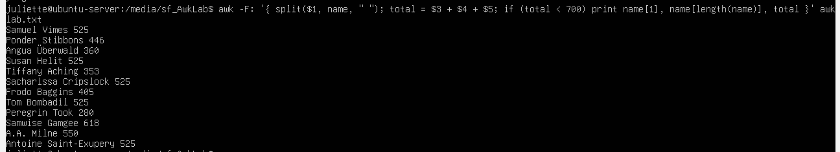
Command: awk -F: ‘{ split($1, name, “ “); total = $3 +$4 +$5; if (total < 700) print name[1], name[length(name)], total }’ awklab.txt
How This command works:
- awk -F: → Starts AWK and uses the colon : to split each line into different fields.
- The curly braces { } contain the actions that AWK runs when the condition in the if statement is true.
- The single quotes '' wrap the AWK action so it runs on each line.
- split($1, name, " ") → Breaks the full name (field 1) into smaller parts like first, middle, last, and stores them in the variable name.
- total = $3 + $4 + $5 → Adds up the three-months contributions to get the total contribution for each person.
- if (total < 700) → Checks if the total contribution is less than 700.
- print name[1], name[length(name)], total → Prints the first name, last name, and the total contribution.
Why this command works:
The -F: divides each line into fields so AWK can separate the names and contributions. The split lets us pull out the first and last names from the full name. We add fields $3, $4, and $5 to find each person’s total contributions. The if statement filters out only those with totals under 700. If the condition is true, AWK goes into { } and prints their first name, last name, and total contribution, exactly like the question asks.
14.Print the first names and first letter of the last name, and average contribution of those who had an average contribution of more than $300
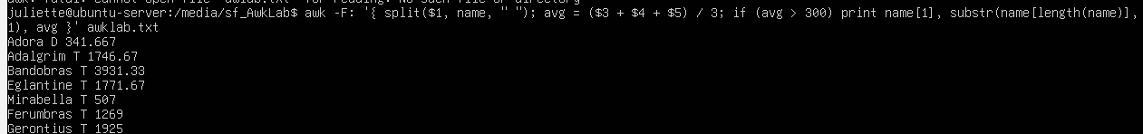
Command: awk -F: '{ split($1, name, “ “); avg = ($3 + $3, + $5) / 3; if (avg > 300) print name[1], substr(name[length(name)], 1,1), avg }’ awklab.txt
How this command works:
- awk -F ":" → tells awk to use the colon : as a divider between the different parts of each line (like names, phone number, contributions).
- { ... } → the curly braces mean: “Do everything inside here for each line.”
- split($1, name, " ") → breaks the first field (which has the full name) into smaller pieces wherever there is a space, and stores them inside the variable name.
- avg = ($3 + $4 + $5) / 3 → adds the 3rd, 4th, and 5th fields (the three months of contributions) and divides by 3 to get the average contribution.
- if (avg > 300) → checks if the average contribution is more than 300. Only if this is true will the next part run.
- print name[1], substr(name[length(name)], 1, 1), avg → this prints three things:
  - name[1] → the first name.
  - substr(name[length(name)], 1, 1) → this is the tricky part
    - name[length(name)] → gets the last piece of the name (the last name).
    - substr(..., 1, 1) → takes the very first letter from that last name.
    - Together, this gives just the first letter of the last name.
  - avg → the average contribution.
- awklab.txt. The file I am working with .
Why this command works:
This command works because awk splits the line using -F ":", so each section (name, phone, contributions) is easy to access. The split helps break the full name into first and last names. Then we calculate the average using fields 3, 4, and 5. The if makes sure we only care about people whose average is above 300. Finally, the print uses name[1] for the first name, and substr(name[length(name)], 1, 1) to grab the first letter of the last name. This matches the requirement: first name, initial of last name, and their average contribution.
- Print the last name and area code of those not in the 916 area code.

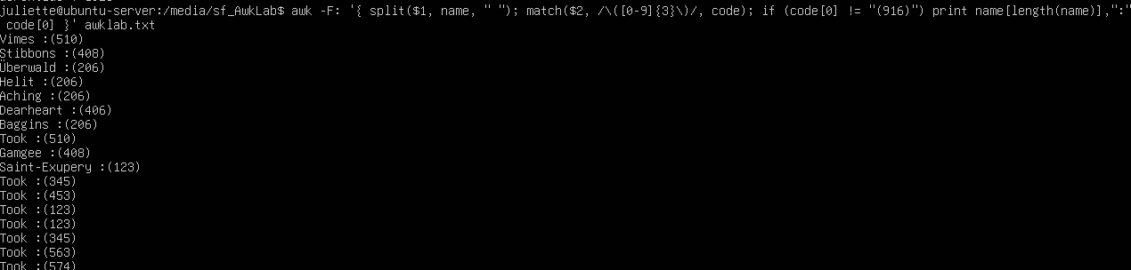
Command: awk -F: ‘{ split($1, name, “ “); match($2, /\([0-9]{3}\)/, code); if (code[0] != “916”) print name[length(name)], “;” code[0] }’ awklab.txt.
How this command works:
- awk -F ":" → Starts awk and uses the colon : as the divider between fields.
- { … } → Curly braces mean: run the instructions inside for every line.
- split($1, name, " ") → Splits the first field (the full name) by spaces and saves the parts in name.
- name[length(name)] → Picks the last piece of the split, which is the last name.
- match($2, /$[0-9]3$/, code) → Looks inside the phone number (field 2), finds the 3-digit area code in brackets, and saves it in code[0].
- if (code[0] != "(916)") → Checks if the saved area code is not (916).
- print name[length(name)] ":" code[0] → Prints the last name, a colon, and the area code which are not 916
Why this command works:
This command works because the -F: separates each line in the file into different fields, so awk can tell the names, phone numbers, and contributions apart. The split is used so I can grab only the last name from the full name. The match then looks at the phone number and pulls out the three-digit area code that sits in the brackets. Once the area code is saved into code[0], the if statement checks that it is not (916). If that condition is true, awk goes into the curly braces and the print shows the last name followed by a colon and the area code. This way we only see people whose area code is not (916).
- Print each record preceded by the number of the record
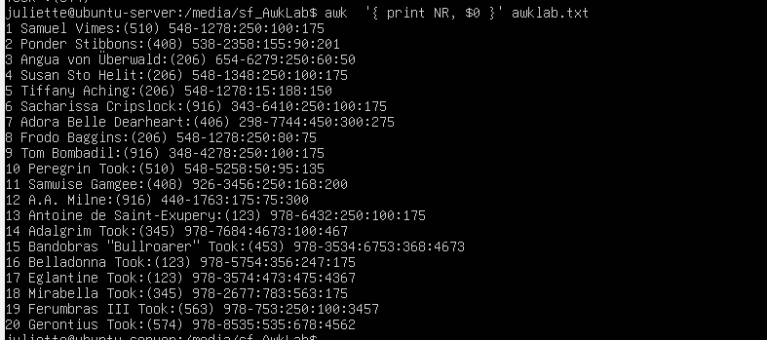
Command: awk -F: ‘{ print NR, $0 }’ awklab.txt.
How this command works:
- awk → runs through the file one line at a time
- -F: tells awk to use the colon (:) as the divider between fields, but here we are not pulling out individual fields like $1 or $2.
- NR → is just the line number. It starts at 1 for the first line, 2 for the second, and keeps counting.
- $0 → means “the whole line.” Instead of picking out just one field, it prints the entire thing.
- print NR, $0 → tells awk to print the line number first, then the line itself.
Why this works:
It works because awk already keeps track of the line numbers using NR, and $0 holds the full line as it is. When I print them together, every record shows up with its line number in front.

- Print the name and total contribution of each person.
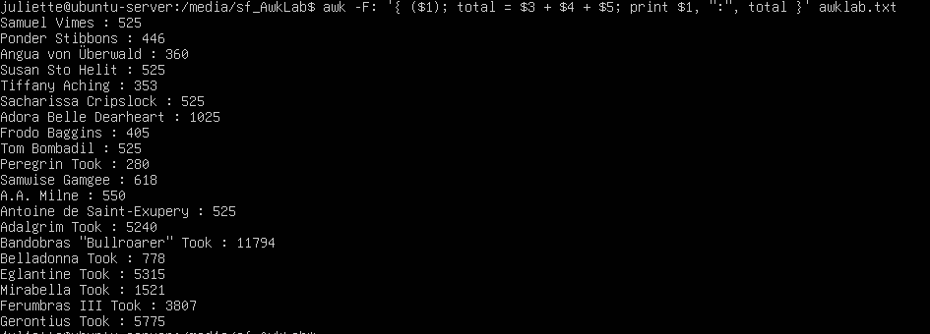
Command: awk -F: ‘{ ($1); total = $3 + $4 + $5; print $1, “1”, total }’ awklab.txt
How this command works:
- awk → This is the command we use to process each line in the file.
- -F: → The -F with a colon tells AWK to divide each line into different fields wherever it sees a colon (:).
- { } → The curly braces wrap the actual action we want AWK to perform on each line.
- ($1); → $1 stands for field 1, which in this file is the full name of each person.
- total = $3 + $4 + $5; → Here we are adding the third, fourth, and fifth fields together. These fields represent each person’s contribution amounts for three different months. We store the result in a variable called total.
- print $1, “:” total → Finally, we print out each person’s name (from field 1) and the calculated total contribution. The : is the colon after the first field(full name)

Why this command works:
This command works because the -F: tells AWK to treat the colon as the divider. That way, $1 becomes the name, and $3, $4, and $5 become the three contributions. We add these three contributions together and save them in total. Finally, the print statement prints each person’s name from $1 and the total contribution $3, $4, $5
- Add $10 to Tiffany Aching’s first contribution and print her full name and first contribution
Command: awk -F: ‘$1 == “Tiffany Aching” { first = $3 + 10: print $1, “:” first }’ awklab.txt.
How this command works:
- awk -F: → tells AWK to use the colon as the divider between sections.
- $1 == "Tiffany Aching" → checks if the first section (the name) is exactly Tiffany Aching.
- { } → curly braces wrap what we want to do if the condition is true.
- first = $3 + 10; → takes her first contribution (field 3), adds 10, and stores the result in a variable called first.
- print $1, “:” first → prints her name (from $1) followed by colon that divides the names and the contributions , and the new updated first contribution.
Why this command works:
This command works because the -F: tells AWK to use the colon as the divider. That means $1 is the full name, $2 is the phone number, and $3, $4, $5 are the three contributions. The condition $1 == "Tiffany Aching" makes sure AWK only looks at her line. Then $3 is her first contribution, and we add 10 to it. Finally, the print shows her full name from $1 and the new first contribution.
- Change Samwise Gamgee’s name to Sean Astin.

Command: awk -F; ‘{ ($1 == “Samwise Gamgee” $1 = “Sean Astin”; print $0 }’ awklab.txt.
How this command works:
- awk -F: → tells AWK to split each line into sections using the colon
- if ($1 == "Samwise Gamgee") → checks the first field ($1) to see if it is exactly the name Samwise Gamgee.
- $1 = "Sean Astin" → if the check is true, it changes the first field ($1) to the new name Sean Astin.
- print $0 → prints the entire line ($0). If the name was changed, the new name shows up, but everything else (phone number and contributions) stays the same.
Why this command works:
This works because AWK splits the line into fields. The first field ($1) is the name, so we can directly test if it equals “Samwise Gamgee.” If it does, we replace it with “Sean Astin.” Printing $0 then shows the whole record with the new name included, while keeping all the other fields untouched.

- Write an awk script to do the following (MUST be an awk script not just a bash script or commands on the commandline) (a) Prints first name of the all the Tooks followed by their total campaign contributions . (b) Print the full names and contributions of anyone who contributed between $10 and $200 in the last contribution (c) Prints the full names and average contribution of those who con tributed less than $300 on average.
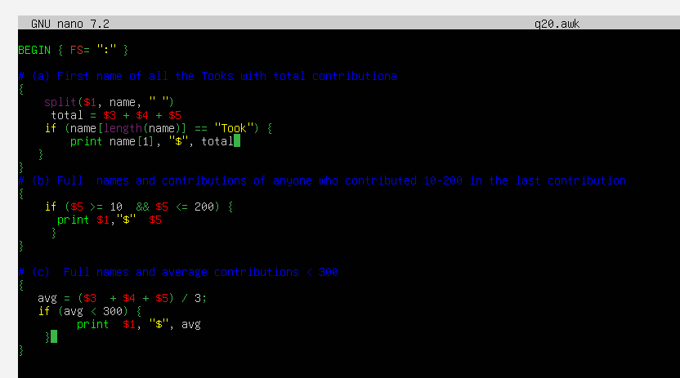
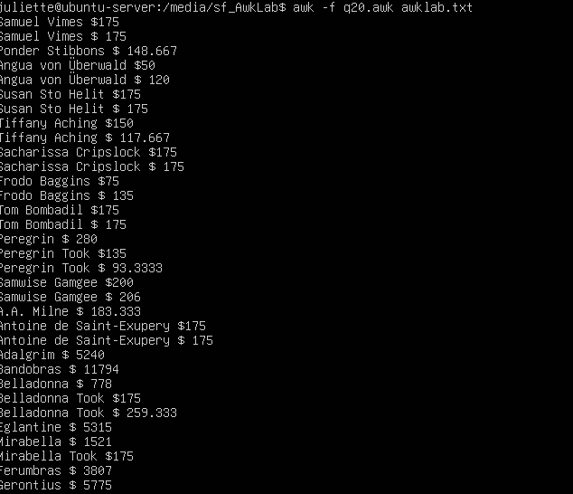

Command: BEGIN{ FS= “:’}
# (a) First name of all the Tooks with total contribution
{
split($1, name, “ “)
total = $3 + $4 + $5
if (name[length(name)] == “Took”) {
print name[1], “$”, total;
}
}
# (b) Full name and contribution of anyone contributed $10 and $200 in the last contribution
{
if ($5 >= 10 && $5 <= 200) {
print $1, “:”, $5
}

}
# (c) Prints the full names and average contribution of those who contributed < 300
{
Avg = ($3 + $4 + $5) / 3
if (avg < 300) {
print $1, “:”, avg
}
}
How this command works:
- BEGIN { FS=":" } → set colon as the field separator.
- split($1, name, " ") → break the full name into first, middle, last parts.
- total = $3 + $4 + $5 → add the three contributions.
- if (name[length(name)] == "Took") { print name[1], total } → check if last name is Took, then print first name and total contributions of all those whose last name is Took
- if ($5 >= 10 && $5 <= 200) { print $1, $5 } → check if last contribution is between 10–200, then print full name of those whose contribution full between this range
- avg = ($3 + $4 + $5) / 3 → calculate the average contribution.
- if (avg < 300) { print $1, avg } → check if average is less than 300, then print full name and average.
Why this command works:
This script works because awk processes the file line by line and splits each record into fields. By using FS=":", each line is divided neatly into name, phone, and contribution fields. Splitting the name again with spaces allows me to isolate the first and last names. Awk can handle arithmetic directly, so adding and dividing the contribution fields is simple. The if statements act like filters, making sure only records that match the conditions are printed. Since all three conditions are written in the same block{}, awk runs through every record once and applies all the checks, which keeps the script efficient and organized.

References:
GeeksforGeeks. AWK Command in Unix/Linux with Examples. Available at: https://www.geeksforgeeks.org/awk-command-unixlinux-examples
The GNU Awk User’s Guide. Free Software Foundation. Available at: https://www.gnu.org/software/gawk/manual/
TutorialsPoint. AWK Tutorial. Available at: https://www.tutorialspoint.com/awk/index.htm
YouTube – ProgrammingKnowledge. Linux Tutorial: Learn AWK Command with Examples. Available at: https://www.youtube.com/watch?v=9YOZmI-zWok

